RESOLUTION NO.__________

RE: CERTIFICATE OF APPROPRIATENESS UNDER THE
PROVISIONS OF THE ACT OF THE PENNSYLVANIA
LEGISLATURE 1961, JUNE 13, P.L. 282 (53
SECTION 8004) AND BETHLEHEM ORDINANCE NO.
3952 AS AMENDED.

WHEREAS, it is proposed install new signage at 310 E. Third St.

NOW, THEREFORE, BE IT RESOLVED by the Council of the City of Bethlehem that a Certificate of Appropriateness is hereby granted for the work.

Sponsored by: (s)

(s)

ADOPTED BY COUNCIL THIS DAY OF

(s)
President of Council

ATTEST:

(s)
City Clerk

HISTORIC CONSERVATION COMMISSION

CASE # 623– It is proposed to install signage for a new business at 310 E. Third St.
OWNER/APPLICANT: Polk Street Development Assoc LP/ Jim Dale/Playa Bowls Bethlehem

The Commission upon motion by Mr. Cornish seconded by Ms. Starbuck adopted the proposal that City Council issue a Certificate of Appropriateness for the proposed work described herein:

- The proposal to install signage for a new business at 310 E. Third St. was represented by Jim Dale.
- The sign will read “Playa Bowls” in black 20” individual letters, pin mounted with 1” standoff from the façade, The letters will have straight edges.
- There will be a 28” diameter logo in the center of the business name.
- 3 or 5 gooseneck lights, in copper or black color, will be installed above the sign.
- Two round white window signs with the logo will be installed and centered on either side window.
- The hours will be installed on the door.

- The motion to approve the proposal was unanimously approved.

CU: cu
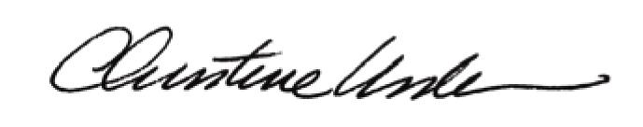

By:

Date of Meeting: August 21, 2017 Title: Historic Officer

